

Online Test Management

Business Requirements Document (BRD)

Version 1.0

Version and Approvals
UTORS
Version History
Version # | Date | Revised By | Reason for change
1 | 6th Sept’ 16 | Vikash Periwal | Initial commit
2 | 11th Sept’ 16 | Vikash Periwal | Modification in scope

This document has been approved as the official Business Requirements Document for Online Test Management, and accurately reflects the current understanding of business requirements. Following approval of this document, requirement changes will be governed by the project’s change management process, including impact analysis, appropriate reviews and approvals.

Document Approvals
Approver Name | Project Role |  | Signature/Electronic Approval | Date
Shridhar Joshi | Mentor |  |  | 21st Sept’ 16

Table of Contents

Project Details 4

Overview 4

Document Resources 4

Project Overview 5
Project Overview and Background 5
Project Dependencies 5
Stakeholders 5

Key Assumptions 6
Key Assumptions and Constraints 6

Use Cases 6
Use Case Diagram (UC01) 6
Use Case Narrative (I) 7
Use Case Diagram (UC02) 8
Use Case Narrative (II) 8

Business Requirements 9
Business Objective 9
Current Challenges 9
Features 10

Project Details

Project Name | Online Test Management (Procured)
Project Type | New Initiative
Project Start Date | 2nd Sept’ 16
Project End Date | 25th Sept’ 16
Project Sponsor | Incture Technologies
Primary Driver | Efficiency
Secondary Driver | Functionality
Division

Overview

This document defines the high level requirements of Online Test Management (Procured). It will be used as the basis for the following activities:

- Creating solution designs
- Developing test plans, test scripts, and test cases
- Determining project completion
- Assessing project success

Document Resources

Name | Business Unit | Role
Deepak Singh | Delivery | Delivery Manager
Meghana Guru | Human Resources | HR Executive
Shridhar Joshi | 1AppMobile | Solution Architect
Karthik V | Human Resources | HR Executive
Rachana Rajeev | Human Resources | HR Executive

Project Overview

Overview and Background
Online Examination System is being launched because a need for a destination that is beneficial for both corporates and students. With this site, companies can register and host online exams. Students can give exams and view their results. This site/app is an attempt to remove the existing flaws in the manual system of conducting exams.

Online Exams System fulfills the requirements of the companies to conduct the exams online. They do not have to go to any software developer to make a separate site for being able to conduct exams online. They just have to register on the site and enter the exam details and the lists of the students which can appear in the exam.

Students can give exam without the need of going to any physical destination. They can view the result at the same time. Thus the purpose of the site is to provide a system that saves the efforts and time of both the institutes and the students.

Dependencies
None

Key Assumptions

Assumptions and Constraints

# | Assumptions
1 | Educational level: Users should be comfortable with English language.
2 | Experience: Users should have prior information regarding the online examinations.
3 | Skills: Users should have basic knowledge and should be comfortable using general purpose applications on computers.
4 | The examinations are all objective. Students can give each exam just once.
5 | The student has only one device and is under invigilator surveillance.
6 | The scope of this app is currently limited to a responsive web (Native apps will be launched in the near future).

Use Cases

Use Case Diagram (UC01)

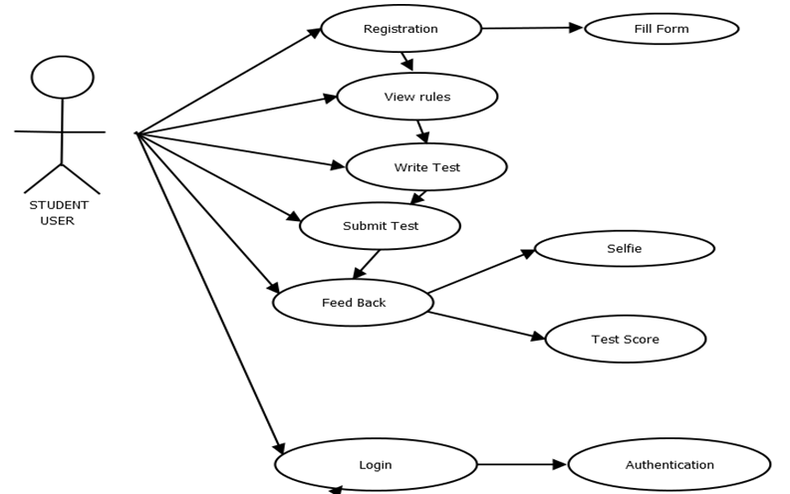

Use Case Narrative (I)

Use Case ID: | UC01
Use Case Name: | Student User
Created By: | Prajwal L | Last Updated By: | Vikash Periwal
Date Created: | 7th September 2016 | Date Last Updated: | 20th September 2016

Actors: | User
Description: | This use case describes the main way this online test platform will be used as a web browser accessed application. The user accesses the appropriate URL and interacts with the functionality made available.
Preconditions: | Web browser opened, test website accessed, and user has been authenticated.
Post conditions: | User navigates from the test website.
Normal Course: | - Open browser.  - Navigate to the website.  - Interact with the online test platform using available functionality.
Alternative Courses: | None
Exceptions: | None
Includes: | None
Priority: | High
Frequency of Use: | Once per visit
Special Requirements: | 24/7 access.  Response time should be less.
Assumptions: | None
Notes and Issues: | --------

Use Case Diagram (UC02)

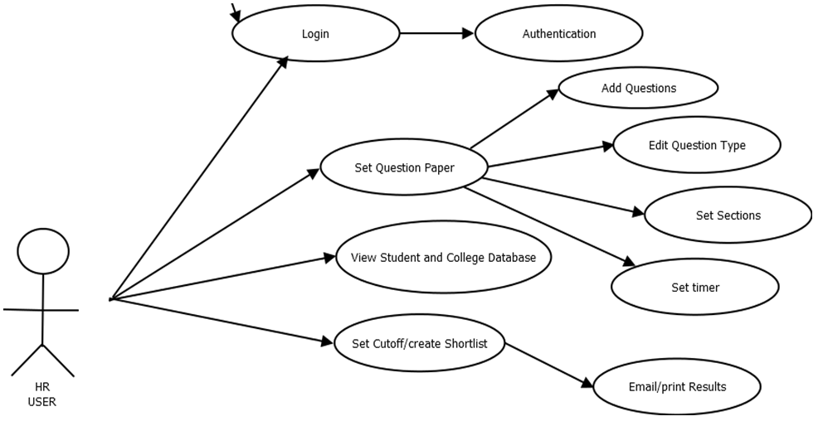

Use Case Narrative (II)

Use Case ID: | UC02
Use Case Name: | HR User
Created By: | Prajwal L | Last Updated By: | Vikash Periwal
Date Created: | 7th September 2016 | Date Last Updated: | 20th September 2016

Actors: | Admin/HR
Description: | This use case describes the main way this online test platform will be used as a web browser accessed application by the admin (test evaluator). The HR accesses the appropriate URL and interacts with the functionality made available.
Preconditions: | Web browser opened, test website opened, & HR has been authenticated.
Post conditions: | HR navigates through the test website changing and updating details of various tests to be conducted
Normal Course: | - Open browser.  - Navigate to the website.  - Interact with the online test platform using available functionality.
Alternative Courses: | None
Exceptions: | None
Includes: | None
Priority: | High
Frequency of Use: | Once per visit
Special Requirements: | 24/7 access.  Response time should be less.
Assumptions: | None
Notes and Issues: | --------

Business Requirements

Business Objective

- One stop platform for all the pre-interview process.
- Reduction of the overheads faced by the HR.
- Maintain details of the all the people taking the test.
- Checking progress report of one’s own test.
- Create various reports and graphs for evaluation purpose almost instantly when and where required.
- To reduce the cost per hire borne by the company.

Current Challenges

- Paper based manual examination which is time consuming and error prone.
- Lack of genuineness and viability of the results.
- Lack of clarity and information about the process
- No provision for the test taker to know his score.
- Excessive overheads faced by the interviewer.

Features

Overall Perspective:

- The application will have a user friendly and menu based interface.
- Following screens will be provided:
- A login screen for entering the username, password will be provided. Access to different screens will be based upon the user.
- There is a screen for displaying information regarding entries to be made by companies.
- There is a screen for displaying information regarding filling of exam details by companies.
- There is a screen for displaying information regarding entering student list for the particular exam.
- There is a screen for entering personal details by the student.
- There is a screen for displaying information menu regarding what options the companies will select while filling entries (entering questions, student list, deleting questions, entering exam details).
- There is a screen for displaying exam details to the students when they are taking exams.
- There is a screen for taking exam for the students.
- There is a screen for displaying of results of students after taking the exam for both admin and the student.

Module Division

Module 1: Login/ Signup

- A simple login module where the students / HR can enter the following details:
User ID (Email ID)
Password
- Only students can sign up on the platform by registering with the following details:
Email ID
Mobile number
- The password would then be sent to the registered email id.

Module 2: Update Details (For User)

After logging into the system, the details mentioned below are required.

- Name
- Date of Birth
- Gender
- Student ID
- Stream
- Degree
- Current CGPA
- Class 12th Credentials
- Class 10th Credentials

Module 3: Create and Schedule Test (For Admin)

The admin can create a test session for a particular college as per his ease. He can also upload questions (Optional).

Module 4: Examination Screen (For User)

- The user can take the test in this screen. There will be only one question displayed per screen to enhance the clarity. The user will also be provided with a mark for review option which enables the user to mark a question for further review.
- The Grid based navigation system gives details about the answered status of all the questions and also allows the user to jump from one question to another directly.

Module 5: Result’s Screen

- The admin will have access to all the results based on colleges and can view a real-time analysis of the same in his/her workbench
- The student can only view his/her own result.

Module 6: Selfie, Share and Review

The test taker will have to take a selfie and write a review about the overall experience. Sharing of test result and experience on social media is optional.

Module 7: Security Vulnerabilities to be tackled

  - The user can ask someone else to take the test on his behalf.
  - While on web,
- The user could open a new tab/window and search the answers over internet
- The user could open a reference document and cheat during the exams

